Stakeholder Requirements:

BI Professional:

Client/Sponsor: Business optimisation manager (BO manager)

Business problem: (the primary question to be answered or problem to be solved)
ultimate goal is to identify top cost drivers to determine the best cost optimisation initiatives. The dashboard you create should demonstrate an understanding of this goal. Primary question: What are the top cost drivers and their categories and which mine is operating within cost targets
Stakeholders: (Who are the major stakeholders of this project, and what are their job titles?)
- BO manager
- Production supervisors
- BI Analyst

Stakeholder usage details: (How will the stakeholders use the BI tool?)
- To identify top costs across the mines
- To understand costs and categories where mines are winning and losing.
- To understand the deviation of actual costs from the target costs for each mine:
Primary requirements: (What requirements must be met by this BI tool in order for this project to be successful?)
- A visual comparing actual and target cost drivers per mine.
- A visual showing cost variance per mine.
- Provide insights that allow users to filter by cost category.
- A chart showing cost trends by mine

Strategy
Users must be able to view actual vs budget cost comparisons over and actual cost trend by month. The dashboard must allow the users to explore the costs by mine/business unit and cost category.

Dashboard Functionality
Dashboard Feature | Your Request
Reference dashboard  [Should this dashboard be modeled on an existing dashboard? | Build a new dashboard
Access  [How should access to the dashboard be limited? Who needs to have access?] | Access will be provided as read-only to the user profiles listed in this document.
Scope  [What data should be included (or excluded) in this dashboard?] | Fields to include: Refer to the relevant document
Date filters and granularity  [Should the dashboard include date filters? If so, what time frame should be displayed by default? Should the dashboard include a “Granularity” drop-down? If so, what granularity should be selected by default?] | Data filters can be applied for the following:  N/A  Can only filter by: Cost_category, Mine

Metrics and Charts

Chart 1
Chart Feature | Your Request
Chart title | Actual vs Target cost drivers
Chart type  [What type of chart needs to be created? This could include any chart type, including a line chart (timeseries), bar chart, or table.] | Bar
Dimension(s)  [What dimensions does this chart need to include?] | MonthDim, BUDim
Metric(s)  [What metrics are relevant to this chart?] | Budget (Rm), Actual (Rm)

Chart 2
Chart Feature | Your Request
Chart title | Cost variance (%) per mine
Chart type  [What type of chart needs to be created? This could include any chart type, including a line chart (timeseries), bar chart, or table.] | Bar
Dimension(s)  [What dimensions does this chart need to include?] | MonthDim, BUDim, Cost_category
Metric(s)  [What metrics are relevant to this chart?] | Cost variance (%)

Chart 3
Chart Feature | Your Request
Chart title | Cost trends by mine
Chart type  [What type of chart needs to be created? This could include any chart type, including a line chart (timeseries), bar chart, or table.] | Line
Dimension(s)  [What dimensions does this chart need to include?] | MonthDim, BUDim
Metric(s)  [What metrics are relevant to this chart?] | Actual (Rm)

Conceptual data

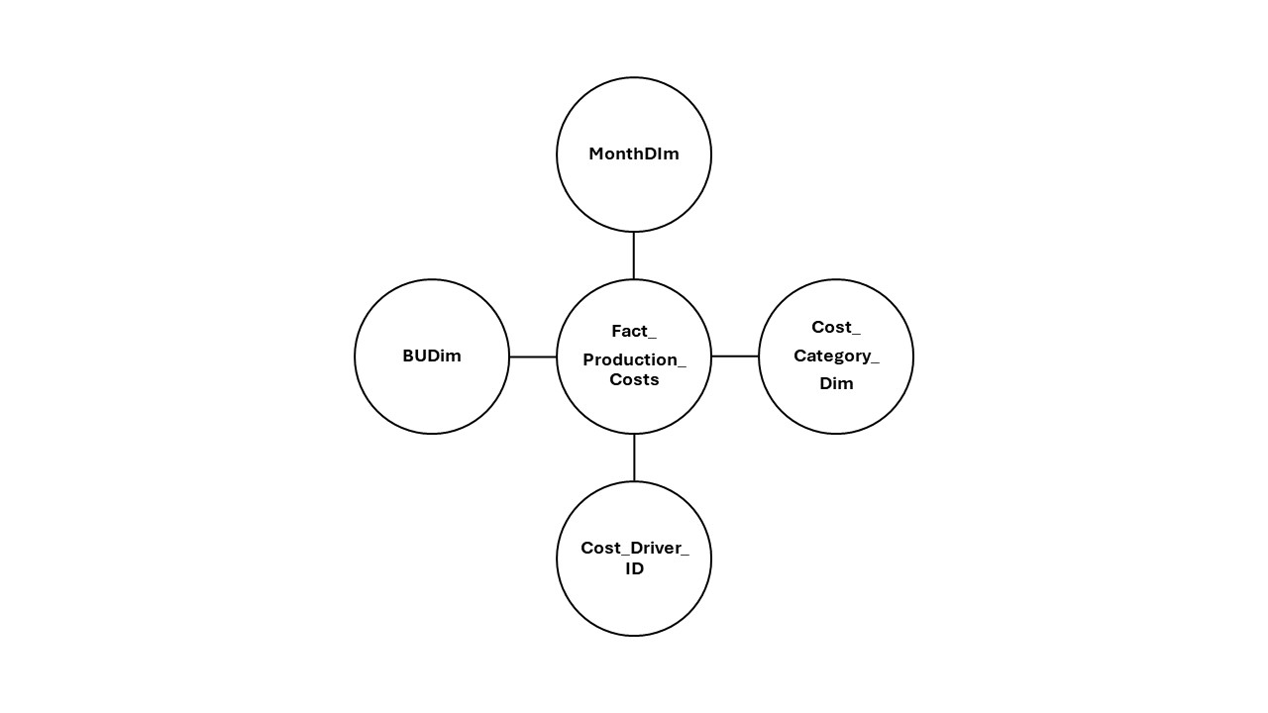

Logical data model

